Radionuclides in Medicine
Information Processing and Data Analysis
Student Worksheet
The following activities have been adapted from Charles Sturt University practical work in the Bachelor of Medical Radiation Science (Nuclear Medicine and Molecular Imaging) developed by A/Prof Geoff Currie. ANSTO would like to express sincere appreciation to A/Prof Currie for his invaluable contribution to the development of this resource and his continued support.
This document provides the opportunity to process and analyse authentic scientific data.
Students will:
- construct tables and graphs using a spreadsheet such as Excel
- analyse their graphs to determine the half-life of each unknown medical radionuclide
- process information from background information, further reading sources and the suggested video to determine the identity and use of each medical radionuclide and answer the questions provided.

The activities address these Australian Curriculum Science Understanding, Science as a Human Endeavour and Inquiry Skills.

Students:
- understand that all matter is made of atoms that are composed of protons, neutrons and electrons; natural radioactivity arises from the decay of nuclei in atoms (ACSSU177)
- understand that people use scientific knowledge to evaluate whether they accept claims, explanations or predictions, and advances in science can affect people’s lives, including generating new career opportunities (ACSHE160)
- analyse patterns and trends in data, including describing relationships between variables and identifying inconsistencies (ACSIS169/ 203)
- Communicate scientific ideas and information for a particular purpose, including constructing evidence-based arguments and using appropriate scientific language, conventions and representations (ACSIS174/ 208)
These activities are suitable for students in Years 9 to 12.

Radionuclides in Medicine

Isotopes are atoms of the same element that have the same number of protons in the nucleus giving them the same atomic number (Z), the number that identifies them on the periodic table, but a different number of neutrons giving each elemental isotope a different atomic mass (A). The atomic mass is the total number of protons and neutrons in a nucleus. Isotopes of the same element have different physical properties, such as melting point and boiling point, but they have the same chemical properties as they are atoms of the same element.

Some isotopes are unstable and radioactive, and are called radioisotopes. Radioisotopes do not have the correct neutron to proton ratio in their nucleus to be stable or they have excess energy. In an attempt to become stable, radioisotopes emit excess particles and/or energy in the form of ionising radiation. The process of emitting ionising radiation is called radioactive decay, and is measured with a time period called a half-life. One half-life is the amount of time it takes for half the radioactive atoms of a radioisotope to disintegrate and, thus, the time taken for a measured level of radioactivity from the radioisotope to reduce to one half of the original level.

While the term radioisotope is widely used in physics, in nuclear medicine the term radionuclide is preferred. Technetium-99 and technetium-99m are the same isotope of the same element, but they have very different levels of radioactivity, half-life, and energy. Technetium-99m is the most commonly used radionuclide in nuclear medicine. The “m” means the nuclide is metastable, that is, at a different energy level to technetium-99. Unless the specific nuclide is metastable, radioisotope is an appropriate term and synonymous with radionuclide.

The half-life is unique to each radionuclide and it tells us how long the radionuclide will remain. One of the units used to measure radioactivity is the Becquerel (Bq), where 1 Bq represents 1 radioactive decay (disintegration) per second.

Radionuclides have been used routinely in medicine for more than 60 years. Nuclear medicine uses radiation to provide information about the functioning of a person's specific organs to determine what is causing the symptoms, disease or injury in a patient (diagnostic), or to treat diseased organs or cancerous tumours (therapeutic). The thyroid, bones, heart, liver, brain and many other organs can be easily imaged, and disorders in their function revealed. Traditionally, nuclear medicine has been concerned with imaging the physiology of organs (studying the way in which tissues and organs function) and disease, while radiology has been focussed on anatomy (studying the structure of tissues, organs and living things). Developments in instrumentation have seen single devices capable of imaging the intricate biological pathways and the anatomy using hybrid systems containing nuclear medicine and computed tomography (CT) devices. At the same time, developments in radionuclides and radiopharmaceuticals have allowed imaging beyond physiology into the molecular level. The radionuclides used in medicine are man-made from materials bombarded by neutrons in a nuclear reactor, or by protons in a particle accelerator called a cyclotron. ANSTO uses both of these methods. ANSTO delivers thousands of patient doses of nuclear medicines to hospitals and nuclear medicine centres in Australia and the region every week.
Most radionuclides used in medicine need to be attached to a biologically active molecule to get to the desired organ. Doctors and chemists have identified a number of chemicals which are absorbed by specific organs. The thyroid, for example, takes up iodine, whilst the brain consumes quantities of glucose. With this knowledge, radio-pharmacists are able to attach various radionuclides to biologically active substances. These radionuclide-tagged molecules are called radiopharmaceuticals. After entering the body, the radiopharmaceutical will accumulate in a specific organ or tumour tissue. The radionuclide attached to the targeting molecule will undergo decay and produce specific amounts of radiation that can be used to diagnose or treat human diseases and injuries. The radiopharmaceutical is incorporated into the normal biological processes and excreted from the body in the usual ways.
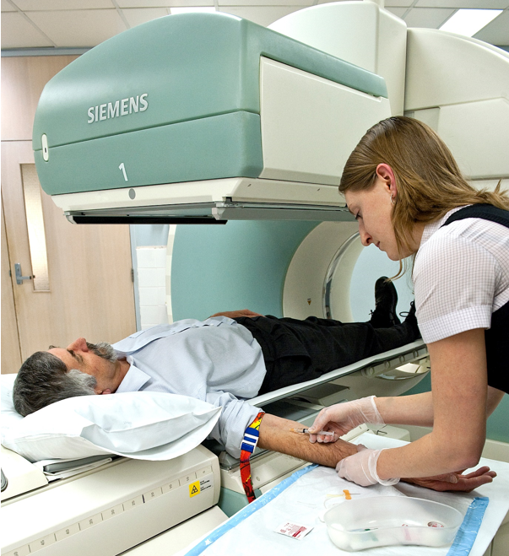
Patient being injected with a diagnostic radiopharmaceutical to undergo a SPECT scan. Over 40 million nuclear medicine procedures are performed each year around the world.

The radionuclides used in medicine have half-lives ranging from a few minutes to several days in order to minimise the radiation dose the patient receives. Diagnostic techniques use radionuclides that emit energy in the form of a gamma photon and are generally short-lived (eg. 6 hours) so they decay away soon after imaging is completed. Indeed, within 10 half-lives of a radionuclide, it has decayed so that the radiation from it is sufficiently low that it cannot be distinguished from background radiation. Radionuclides which have longer half-lives (measured in days rather than hours) and take more time to decay, are suitable to treat diseased organs or tumours. The radionuclide used in each case is chosen for its appropriate type of emission, half-life and energy in order to get the best treatment, diagnosis or information possible with minimal harm to normal organ tissue. They generally decay to become stable (non-radioactive) elements and/or they are rapidly eliminated from the body.

Some medical radionuclides give off alpha or beta radiation (particles), and these are used for treating diseases such as cancer. They are administered as radiopharmaceuticals that target specific characteristics of tumours, such as over expression of certain receptors on cell surfaces. These particles can only travel a few mm in the body and so deposit their high amount of energy in the targeted tissue (tumour or other disease), causing lethal damage to the cells. Other medical radionuclides used for diagnostic scans decay via gamma or positron emission, producing gamma rays of sufficient energy to escape from the body. Gamma cameras and PET (positron emission tomography) scanners register the origin of the gamma rays and build up an image that represents the radiopharmaceutical distribution throughout the body or targeted organ, providing a view of the position and concentration of the radionuclide within the body. This image is enhanced by a computer and viewed on a monitor for indications of abnormal conditions. Single photon emission computerised tomography (SPECT) and PET produce tomographic projections that allow organs to be viewed in 3 dimensions to produce higher accuracy. Both SPECT and PET are typically hybrid scanners that include high resolution diagnostic CT capability. For more than 60 years ANSTO has manufactured a range of radiopharmaceuticals which are used as diagnostic and therapeutic agents. Every day many Australians benefit from the radiopharmaceuticals produced at ANSTO.
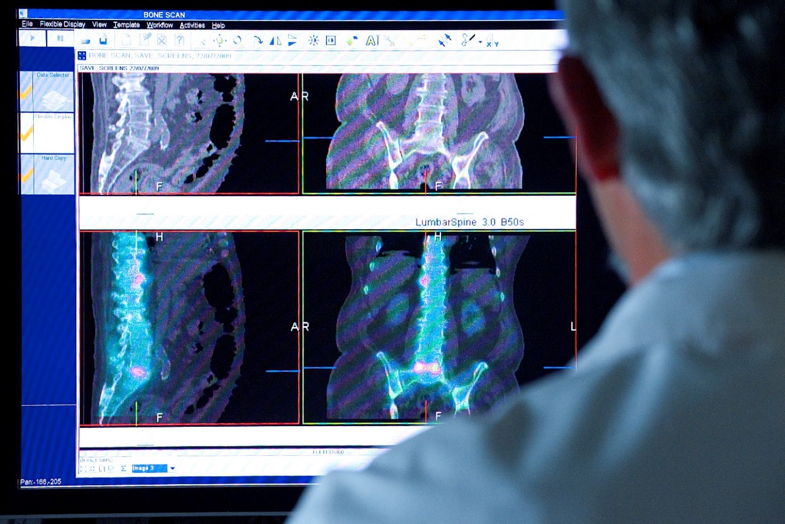
Doctor viewing SPECT scan of a patient. Organ malfunction can be indicated if the isotope is either partially taken up in the organ (cold spot), or taken up in excess (hot spot).

Further background reading for students
Before beginning the activities, read the background information provided on Radionuclides in Medicine and view the videos and articles listed here.
Use the information presented in these sources to assist you in answering the questions in the tasks.

- https://www.ansto.gov.au/education/nuclear-facts/what-are-radioisotopes
- What are radioisotopes?
- Radioisotopes in medicine

- https://www.ansto.gov.au/education/nuclear-facts/what-is-radiation
- What is radiation?
- Frequently asked questions

- https://www.youtube.com/watch?v=oySvkmezdo0
- PET scan animation

- https://www.youtube.com/watch?v=xO_HtDCp3ZE&t=13s
- Clinical uses of nuclear medicine

Determining the half-life of radionuclides used in nuclear medicine

Use the background information on Radionuclides in Medicine and the sources recommended in the further background reading to assist you in answering the following questions.

- Oxygen is element number 8 in the periodic table. It has three stable isotopes, which are identified by their atomic mass.

Complete the table for each of the three stable isotopes of oxygen.
Stable Isotopes of the element Oxygen (O)

Atomic Mass (A) | Proton number (Z) | Neutron number (N) | Electron number of neutral atom
16
17
18

- Oxygen-15 is a radioactive (unstable) isotope of oxygen, used in PET imaging.

Describe the conditions for which an isotope is unstable.
………………………………………………………………………………………………………………………………………………………………………………………………………………………………………………………………………………………………………………………………………………………………………………………………………………………………………………………………………

- Explain the difference between a radionuclide and a radiopharmaceutical. Give an example of each from the PET scan animation (https://www.youtube.com/watch?v=oySvkmezdo0)

…………………………………………………………………………………………………………………………………………………………………………………………………………………………………………………………………………………………………………………………………………………………………………………………………………………………………………………………………………………………………………………………………………………………………………
……………………………………………………………………………………………………………………………………………………………………………………………………………………………………………………………………………………………………………………………………………………………………………………………………………………………………………………………………………………………………………………………………………………………………………….........................................................................................................................................
- Explain how the radionuclide in the PET scan animation can be used to detect cancerous tumours in humans.

…………………………………………………………………………………………………………………………………………………………………………………………………………………………………………………………………………………………………………………………………………………………………………………………………………………………………………………………………………………………………………………………………………………………………………
…………………………………………………………………………………………………………………………………………………………………………………………………………………………………………………………………………………………………………………………………………………………………………………………………………………………………………………………………………………………………………………………………………………………………………

- Some radionuclides give off alpha or beta radiation, and some give off gamma radiation. Complete the table below to show the difference between each of these ionising radiations.
(HINT: Use the information provided at https://www.ansto.gov.au/education/nuclear-facts/what-is-radiation to help you.)

Ionising radiation | Description of this radiation | Stopped by
alpha

beta

gamma

- Define the term half-life, and explain why half-life is so important for a radionuclide used in nuclear medicine.

…………………………………………………………………………………………………………………………………………………………………………………………………………………………………………………………………………………………………………………………………………………………………………………………………………………………………………………………………………………………………………………………………………………………………………
………………………………………………………………………………………………………………………………………………………………………………………………………………………………………………………………………………………………………………………………………………………………………………………………………………………………
Watch the video below from time 0:29 to 1:55.
https://www.youtube.com/watch?v=FaUUafDRcQE&index=27&t=0s&list=PLZZsi0PZ38Jd4gaXX8lfTI-mlITdP3MyM

The dose calibrator in the video records the activity of the radiopharmaceutical in mega becquerels (MBq). What is a Becquerel?

………………………………………………………………………………………………………………………………………………………………………………………………………………………………………………………………………………………………………………………………………………………………………………………………………………………………

- Three different unknown radiopharmaceuticals were separately placed in the dose calibrator as presented in the video. The activity of each source was recorded in counts per second (cps) at various times as shown below.
Source 1 |  |  | Source 2 |  |  | Source 3
Time | Activity |  | Time | Activity |  | Time | Activity
0 | 1250 cps |  | 0 | 900 cps |  | 0 | 450 cps
15 min | 1215 cps |  | 1 hr | 892 cps |  | 1 hr | 448 cps
30 min | 1180 cps |  | 2 hr | 884 cps |  | 2 hr | 447 cps
45 min | 1146 cps |  | 3 hr | 876 cps |  | 4 hr | 443 cps
1 hr | 1114 cps |  | 4 hr | 868 cps |  | 8 hr | 437 cps
2 hr | 992 cps |  | 6 hr | 852 cps |  | 24 hr | 413 cps
4 hr | 788 cps |  | 12 hr | 809 cps |  | 36 hr | 395 cps
24 hr | 78 cps |  | 36 hr | 654 cps |  | 168 hr | 246 cps
 |  |  | 168 hr | 202 cps |  | 400 hr | 107 cps

For each of the 3 sources, use an EXCEL spreadsheet to construct a table to show the data for that unknown radiopharmaceutical. Construct each of the tables on a separate page (worksheet) of the spreadsheet.

Remember:
- use the same units for time for each of the sources.
- your table must have rows and columns with appropriate headings, and should include units in the headings, not in the body of the table.
- the data and headings should all be enclosed by lines (borders).
- your table should also have a descriptive title.

The requirements for the construction of tables have been sourced from
https://education.nsw.gov.au/teaching-and-learning/curriculum/key-learning-areas/science/stages-4-and-5/programming/working-scientifically
Guidelines for working scientifically skills (DOC 638KB) External link includes guidance for creating diagrams, flow charts, graphs and charts and tables.

- For each of the 3 sources, use EXCEL to construct a ‘scatter graph with only markers’ of Activity versus time.
For the graph of Source 1, fix the major unit on the vertical axis at 100 and the minor unit at 10, and fix the major unit on the horizontal axis at 5 and the minor unit at 1.
For the graph of Source 2, fix the major unit on the vertical axis at 50 and the minor unit at 10, and fix the major unit on the horizontal axis at 10 and the minor unit at 1.
For the graphs of Source 3, fix the major unit on the vertical axis at 50 and the minor unit at 5, and fix the major unit on the horizontal axis at 50 and the minor unit at 5.
Show all gridlines. You will need to increase the size of your graphs so that you can clearly see all of the minor gridlines.
Add an exponential trendline for each of your graphs.

HINT: You can use the following steps to create your charts:
For source 1:

- Highlight the data in both the time column and the Activity column in your table. Do not include the column headings.
- On the Insert tab, in the Charts group, click the Scatter symbol.
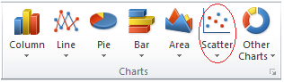
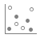
- Click scatter graph with only markers.

- Add chart title and axis titles for both Primary Horizontal axis and the Primary Vertical axis. (For Excel 2013, click on your graph and then click on Design tab in Chart Tools. Add Chart Elements appears on left hand side of tool bar. Click here for Axis Titles and Chart Title.)
- Right-click the x axis labels (horizontal axis) and select Format Axis in the dialog box.
For Units type 5.0 for major and 1.0 for minor.
Click on TICK MARKS and for Major type select outside.
- Right-click the y axis labels (vertical axis) and select Format Axis in the dialog box.
For Units type 100.0 for major and 10.0 for minor.
Click on TICK MARKS and for Major type select outside.
- Increase the size of your graph so that it is about 20 cm high x 15 cm across. Hover the mouse cursor over a corner of the graph and a double headed arrow appears. Click and drag to the appropriate size.
- To show the gridlines, click on your graph and then click on Design tab in Chart Tools. Add Chart Elements appears on left hand side of tool bar. Click here and scroll down to gridlines, then select Primary Major Horizontal. On your graph, double click on one of these gridlines then click on paint pot icon in the dialog box that opens on the right hand side. For color choose a dark grey/ black. Repeat for Primary Major Vertical.
- Repeat for Primary Minor Horizontal but choosing a medium grey for colour. Repeat for Primary Minor Vertical.
- To add a trendline, click on your graph and then click on Design tab in Chart Tools. Add Chart Elements appears on left hand side of tool bar. Click here and scroll down to trendline, then select exponential.

- For each of the radiopharmaceuticals tested (that is, sources 1, 2 and 3):

- use your graph to determine the half-life of the unknown radionuclide. Record the value in the table below.
(HINT: find the time for which the radionuclide has decayed to half of its initial activity.)

use the half-life to identify the medical radionuclide used from the list of reactor-produced medical radioisotopes and cyclotron-produced medical radioisotopes provided at the following website https://www.ansto.gov.au/education/nuclear-facts/what-are-radioisotopes

Record your answer in the table.

outline the use of the identified medical radionuclide and record it in the table.

Radiopharmaceutical  source | Half life | Identified radionuclide | Use of radionuclide when labelled to various pharmaceuticals
1
2
3

- Explain the difference between a diagnostic radionuclide and a therapeutic radionuclide for internal nuclide therapy in terms of its purpose and characteristics.

…………………………………………………………………………………………………………………………………………………………………………………………………………………………………………………………………………………………………………………………………………………………………………………………………………………………………………………………………………………………………………………………………………………………………………
……………………………………………………………………………………………………………………………………………………………………………………………………………………………………………………………………………………………………………………………………………………………………………………………………………………………………………………………………………………………………………………………………………………………………………….........................................................................................................................................

- One of the radionuclides you have identified accounts for around 85% of diagnostic scans in nuclear medicine worldwide. ANSTO is one of only 6 reactors worldwide producing its parent radionuclide, molybdenum-99, for the global supply.
From your background reading, describe how this radionuclide is produced by ANSTO and explain the characteristics of this radionuclide that make it so useful for diagnostic purposes.
…………………………………………………………………………………………………………………………………………………………………………………………………………………………………………………………………………………………………………………………………………………………………………………………………………………………………………………………………………………………………………………………………………………………………………
……………………………………………………………………………………………………………………………………………………………………………………………………………………………………………………………………………………………………………………………………………………………………………………………………………………………………………………………………………………………………………………………………………………………………………….........................................................................................................................................
…………………………………………………………………………………………………………………………………………………………………………………………………………………………………………………………………………………………………………………………………………………………………………………………………………………………………………………………………………………………………………………………………………………………………………
………………………………………………………………………………………………………………………………………………………………………………………………………………………………………………………………………………………………………………………………………………………………………………………………………………………………
Extension Activity: Radioactive Decay Law

Radioactive decay is a random process at the level of single atoms. It is impossible to predict when a particular atom will decay. Thus, the probability of its disintegration does not increase with time, but stays constant no matter how long the nucleus has existed. Hence the probability per unit time that a nucleus will decay is a constant, independent of time, called the decay constant, λ .

The following equation, known as the radioactive decay law, allows you to quantitatively predict the amount of a radioactive sample that still remains and has not yet decayed after a time t, where
N_{t} = number of radioactive nuclei present at time t, and N₀ = the initial number of radioactive nuclei present (that is, at t = 0)
N_{t} = N₀e^{-λt}
The number of radioactive nuclei present at time t (N_{t}) is proportional to the level of radioactivity of the source. Hence the radioactive decay law can also be represented by
A_{t} = A₀e^{-λt}
where λ = ln(2)
t_{1/2}
where A_{t} = the activity of the sample at time t,
A₀ = the initial activity of the sample that is the activity at t = 0,
λ = decay constant,
t_{1/2} = time for half the radioactive amount to decay,
ln 2 (the natural log of 2) equals 0.693.

By rearranging the first equation above we can form the following equation:
ln A_{t} = – λt + ln A₀
which is in the form of the equation for a straight line y = mx + b,
where m is the gradient (or slope) of the line, and b is the y-intercept (where the line meets the y axis).
So by using the gradient (slope) of the straight line we can determine the half-life of the radionuclide using
m = – λ = - 0.693
t_{1/2}

- For each of the 3 radionuclide sources, add a column to your EXCEL table for ln(Activity) and construct a ‘scatter graph with only markers’ of ln(Activity) versus time.
Add a trendline to your graph and include the equation of the trendline on the chart and display the R-squared value on the chart. A trendline is most reliable when its R-squared value is at or near 1.

HINT: You can use the following steps to create your chart:

- Add a third column to your EXCEL table for the source by typing ln (Activity) in the heading row.
- In the first data cell of the ln (Activity) column (that is, the cell in the row for time 0 hours), type =, then click on the formula tab, choose math and trig and scroll down to select LN. A dialog box will open. Click on the activity value for time 0 hours – this cell location will show in the brackets and in the number of the dialog box. Select OK on the dialog box and a number will appear in the highlighted cell.

- Hold the cursor over the bottom right hand corner of this cell, click, hold and drag the cursor to the last data cell in this column in the table. This will fill in the values for ln(Activity) for all the other times.
- Highlight the data in time column and, with the Control button depressed, highlight the data in the ln(Activity) column. Do not include the column headings.
- On the Insert tab, in the Charts group, click the Scatter symbol.
- Click scatter graph with only markers.
- Add chart title and axis titles for both Primary Horizontal axis and the Primary Vertical axis. (For Excel 2013, click on your graph and then click on Design tab in Chart Tools. Add Chart Elements appears on left hand side of tool bar. Click here for Axis Titles and Chart Title.)
- Click Add Chart Elements, then scroll down to Trendline and select More Trendline Options.
- In the dialog box, choose linear, Display equation on chart and Display R-squared value on chart. A line equation in the form of y = m x + b will be shown.

- For each of the three radionuclide sources, use the equation of the trendline to find the gradient (slope) of the trendline, and hence determine the half-life of the radionuclide using the formula shown in the table.
Record these values in the table.

Radionuclide | gradient of line (m) | half life, t_{1/2}= - 0.693  m
1
2
3

- Compare the value of the half-life determined using the line of best fit (trendline) with that determined from the graph of activity Vs time for each of the radionuclides. Comment on the accuracy of the values.

………………………………………………………………………………………………………………………………………..………………………………………………………………………………………………………………………………………..………………………………………………………………………………………………………………………………………...……………………………………………………………………………………………………………………………………….………………………………………………………………………………………………………………………………………..
………………………………………………………………………………………………………………………………………...……………………………………………………………………………………………………………………………………….………………………………………………………………………………………………………………………………………..………………………………………………………………………………………………………………………………………..………………..........................................................................................................................................................................................................................................................................
………………..........................................................................................................................................................................................................................................................................
- The radioactive decay law in terms of radioactivity of the source is shown below. This equation can be rearranged to enable us to use the initial activity of the radioisotope (A_{o}) and the activity of the radioisotope at any time (A_{t}) to determine the decay constant λ.
A_{t} = A₀e^{-λt}

The decay constant equation can then be used to calculate the half-life of the radioisotope using the following equation:
λ = ln(2)
t_{1/2}

For each of the radionuclides, use the activity after 4 hours stated in your excel table to calculate the half-life of the radionuclide. Record your information in the table below.

HINT: to determine the decay constant λ rearrange the first equation above to form the equation
λ = - ln ($\frac{At}{Ao}$)
t
then use the rearranged equation t_{1/2}= ln(2) to determine the half-life t_{1/2}
λ

Radionuclide | Initial activity  (A_{o}) | Activity after 4 hours (A_{t}) | calculated half life
1
2
3

