Year 12 Investigating Science
Excursion workbook
Your visit to ANSTO
On site, you will visit:
- The OPAL (Open Pool Australian Lightwater) Research Reactor
- The Australian Centre for Neutron Scattering
- The Centre for Accelerator Science
- The ANSTO Nuclear Medicine Facility

Back at the Discovery Centre, you will:
- Draw traces left by alpha particles, beta particles, protons and muons in the cloud chamber
- Observe demonstrations of devices for measuring/detecting radiation (scintillation counter, thermoluminsecent device, dosimeter)
- Process information to learn how the Australia Synchrotron accelerates electrons to produce intense light for research purposes
- Process information to learn how the fission reaction in the OPAL reactor is controlled

The tour will conclude at the Discovery Centre. We have a number of brochures that you may wish to collect or they can be accessed on our website.

Year 12 Investigating Science: Nuclear Science Depth Study
We recommend that this excursion becomes the starting point for a nuclear science depth study. ANSTO’s Year 12 Investigating Science excursion helps students cover the following syllabus content:
Module 6: Technologies
Students:
• Using examples, assess the impact that developments in scientific theories, laws and models have had on the development of new technologies, including but not limited to:
- radioactivity and radioactive decay on the development of radiotherapy and nuclear bombs
• Using examples, assess the impact that developments in technologies have had on the accumulation of evidence for scientific theories, laws and models, including but not limited to:
- technology to detect radioactivity and the development of atomic theory
Module 8: Science and society
Students
• Investigate case studies of past events to consider how they have affected the public image of science, including but not limited to:
- meltdowns of nuclear reactors
• Investigate and assess ethical issues surrounding current scientific research in, for example:
- use of radiation
• Investigate the need for the regulation of scientific research in, for example:
- products and processes of the nuclear industry
• Evaluate how scientific research aids economic development and human progress in relation to, for example:
- nuclear power generation
• Evaluate the impacts of scientific research, devices and applications and world health and human wellbeing.

Working Scientifically
- Questioning and predicting
- Processing data and information
- Analysing data and information
- Problem solving
- Communicating

We recommend students use our Year 12 Investigating Science Depth Study Workbook for ideas and resources for depth study activities after their excursion.

NESA requirements for Depth Studies
- A minimum of 30 hours of in-class time is allocated in both Year 11 and Year 12
- At least one depth study must be included in both Year 11 and Year 12
- The two Working Scientifically outcomes of Questioning and Predicting, and Communicating must be addressed in both Year 11 and Year 12
- A minimum of two additional Working Scientifically skills outcomes, and further development of at least one Knowledge and Understanding outcome, are to be addressed in all depth studies.

Pre-work Questions
We expect students to have completed this pre-work prior to attending the tour. The first seven questions are a review of radioactivity essential for an understanding of the basic nuclear science on the tour. The remaining questions are about content and skills specific to the Year 12 Investigating Science syllabus.

Question 1
Atoms are made up of 3 sub-atomic particles: protons, neutrons and electrons. Choose options from the following lists to complete the table:

in nucleus | negligible | 0
surrounding the nucleus | 1 | +1
in nucleus | 1 | -1

Particle | Location | Mass in atomic mass units (amu) | Charge
Proton
Neutron
Electron

Nuclear Facts To Remember:
- The number of protons in an atom is the atomic number (Z).
- The number of protons plus neutrons is the mass number (A).
- In a neutral atom, the number of protons and number of electrons are equal.

The atomic number, Z, determines what element the atom is, for example:
Z = 1, atom is hydrogen, symbol H
Z = 6, atom is carbon, symbol C

The notation for representing an atom is as follows:
X
A
Z
X = symbol of element
A = number of (protons + neutrons)
Z = number of protons

As the symbol or the Z-number uniquely identifies the element, only one of these must be present.
When naming atoms, we use the name or symbol of the element, followed by the mass number. For example: hydrogen-1 (or H-1) and carbon-12 (or C-12). The notation for these is:
₁ ₁ ₁₂ ₁₂
H or H and C or C
¹ ⁶

Question 2
Use the online Atom Builder program (https://www.ansto.gov.au/education/apps) and the Periodic Table poster (https://www.ansto.gov.au/education/resources/posters) to help complete the table.

Name of atom | Number of protons | Number of neutrons | Mass number | Notation
nitrogen-14
 | 3 |  | 7
F
19
9

 |  | 14 | 27

Isotopes of Elements
The nuclei for the five smallest atoms and their names are shown in the diagram below. Nearly all atoms contain protons and neutrons. Hydrogen-1 is the only isotope that does not contain neutrons.
++
++
++
++
++
++
++
++
++
Key: proton neutron
Isotopes of helium
Isotopes of hydrogen

hydrogen-1 hydrogen-2 hydrogen-3 helium-3 helium-4
(deuterium) (tritium)

Question 3
Using the information above, define the term ‘isotope’
___________________________________________________________________
___________________________________________________________________

Electromagnetic spectrum
The electromagnetic spectrum below shows that radiation occurs in waves. The type of radiation depends on the amount of energy it has. Gamma rays are at the high energy end of the spectrum whilst radio waves are at the low energy end.

Question 4
Refer to the ANSTO Electromagnetic Spectrum poster (shown above and also at https://www.ansto.gov.au/education/resources/posters) to complete the activity below:
Delete the incorrect terms in the following sentence.
The shorter the wavelength, the greater/lower the energy. Therefore ultraviolet radiation has more/less energy than infrared radiation but more/less than gamma rays.
Nuclear Radiation – Radioactivity
In 1896 French scientist Henri Becquerel discovered a new kind of invisible radiation that seemed to be emitted from a uranium-rich rock. This radiation could not be stopped, increased or decreased. This was nuclear radiation and it was something completely new to science.
Marie Curie, working in Paris, coined the term 'radioactivity' to describe this new property, and discovered three new radioactive elements.
It is the structure of the nucleus of an atom that determines whether it is radioactive, or in other words, unstable. Unstable atoms undergo radioactive decay.
Further studies by New Zealander Ernest Rutherford showed that there are three different types of radioactivity. He named them after the first 3 letters of the Greek alphabet: alpha (α), beta (β) and gamma (γ) radiation.
Alpha radiation (α)
Strong nuclear forces normally hold the protons and neutrons inside a nucleus together. But if the nucleus is too big, it will begin to break down and release an alpha particle.
An alpha particle is made up of two protons and two neutrons, has a charge of +2, and is identical to a helium nucleus.
Alpha particles have high energy when they are first released but quickly lose energy as they strike matter. Because alpha particles are relatively large, they have a low penetrating ability. They only travel a few centimetres through air and can be stopped by a sheet of paper or the outer layer of dead skin.
Beta radiation (β)
Nuclei are made up of protons and neutrons. If a nucleus contains too many neutrons, one of the neutrons will break down. A neutron breaks down to form a proton (which stays in the nucleus) and an electron (which is emitted as a beta particle).
Beta particles have a charge of -1, are much smaller than alpha particles, and have a higher penetrating ability. Beta particles can pass through skin but can be stopped by a small thickness of aluminium or plastic.
Gamma radiation (γ)
Sometimes a nucleus is still unstable after emitting an alpha or a beta particle and balances itself by releasing a burst of energy in the form of a gamma ray.
Gamma radiation consists not of particles but of energy in the form of extremely high-frequency electromagnetic waves.
Gamma radiation has the highest penetrating ability of all nuclear radiation. A thick layer of lead, concrete or several meters of water is needed to stop it.

Question 5
After reading the information above, complete the following table for the three types of radioactive decay.
Name | Symbol | Consists of | Charge | Stopped by
Alpha | α | Two protons and two neutrons (Helium-4 nucleus)
Beta | β
Gamma | γ |  | 0

Radioactive atoms, called radioisotopes, may emit only one type of radiation but it is more common for an alpha or beta decay to be accompanied by a gamma emission.

Question 6
Isotopes are unstable if:
- They have too few neutrons
- They have too many neutrons
- Their nucleus is too large
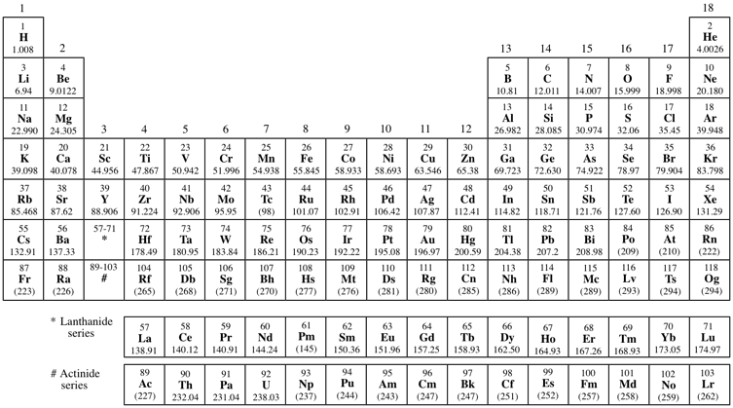
Use the ANSTO periodic table (https://www.ansto.gov.au/education/resources/posters) to identify elements in the periodic table that are always unstable. Highlight these on the diagram below.

Question 7
Every unstable isotope undergoes radioactive decay at a particular rate. This rate is referred to as the half-life of an isotope. Half-lives may be very short, just a few nanoseconds, or very long, up to many millions of years, depending on the isotope. Carbon-14 has a half-life of 5,730 years.

Examine the following diagram and, from it, explain the meaning of the term ‘half-life’.
one half-life
5,730 years
another half-life
another 5,730 years
20 million C-14 atoms
10 million C-14 atoms
5 million C-14 atoms

___________________________________________________________________
___________________________________________________________________
___________________________________________________________________

Question 8
A nuclear reactor relies on harnessing the nuclear fission process.
In the box below, draw a diagram to represent this process.

Explain how the fission process is used to produce electricity in a nuclear power reactor.
___________________________________________________________________
___________________________________________________________________
___________________________________________________________________

Question 9: Applications of nuclear science at ANSTO
ANSTO uses nuclear science in many different ways. Our OPAL reactor produces nuclear medicines for millions of patients every year, irradiates silicon for the electronics industry, and produces neutrons for investigating materials at the atomic and molecular level. Our scientists and engineers use nuclear science to advance our understanding of the environment, human health and new materials.
Watch a selection of videos from https://www.youtube.com/user/ANSTOVideos and briefly summarise three examples of how nuclear science is used to benefit society at ANSTO:
___________________________________________________________________
___________________________________________________________________
___________________________________________________________________
___________________________________________________________________
___________________________________________________________________
___________________________________________________________________
___________________________________________________________________
___________________________________________________________________
___________________________________________________________________
___________________________________________________________________

Question 10: Research data sets from ANSTO
Some of our scientists have supplied real data sets from their research projects for you to analyse. Select and complete the student worksheet for one of these data sets: https://www.ansto.gov.au/education/secondary/workbooks-and-datasets

During excursion questions

Complete your answers to the following questions in point form as you move around the site. More detailed information is available on the ANSTO website at https://www.ansto.gov.au/

Fission in a nuclear reactor is controlled, whereas fission in a nuclear weapon is uncontrolled.

Controlled fission in a reactor requires certain reactor components shown in the table. Complete the table below by indicating the function of these components and the material used for these components in the ANSTO’s OPAL multipurpose research reactor.

Reactor component | Material used in OPAL | Function
Fuel
Moderator

Control plates
Coolant

Outline the shutdown processes for the OPAL reactor.
___________________________________________________________________
___________________________________________________________________
___________________________________________________________________
___________________________________________________________________
___________________________________________________________________
Identify 3 products from OPAL and outline their uses.

Product of ANSTO | Use

When ANSTO Nuclear Medicine (ANM) facility is operational, how will ANSTO manage the intermediate level waste?
___________________________________________________________________
___________________________________________________________________
___________________________________________________________________
___________________________________________________________________
___________________________________________________________________

At the Discovery Centre

Station 1 – Cloud Chamber
A cloud chamber allows us to see the effect of different nuclear radiation. Radioactive particles move through the supersaturated alcohol vapour in the cloud chamber and strip electrons from surrounding atoms in the air. The alcohol vapour then condenses on the charged particles, leaving a trail of droplets along the path. These tracks disappear almost immediately.
Read the information about the different types of nuclear radiation.
1. Look in the cloud chamber and observe the white vapour trails produced by different particles.
2. Draw the trails left by each particle and describe the trail and length of time it lasts.

Alpha

Beta

Proton

Station 2 – Measuring radioactivity
Your Education Officer will demonstrate how to use a scintillation counter to measure radioactivity from an object.
You will follow their instructions and use the scintillation counter to measure the radioactivity from a range of objects.
- Which object is the most radioactive?
________________________________________________________________

- Increase the thickness of a shielding material (paper) between the source and the detector, and record how the detected level changes in the table below. (Use the most radioactive object stated above).

Construct a graph to illustrate how radioactivity changes as the thickness of the shielding material between the source and the detector increases.

Station 3 – Australian Synchrotron
Observe the interactive model of the Australian Synchrotron in the Discovery Centre.
- Label the diagram below with the following options:

End station Electron gun Booster ring
Linear accelerator Storage ring Beamline
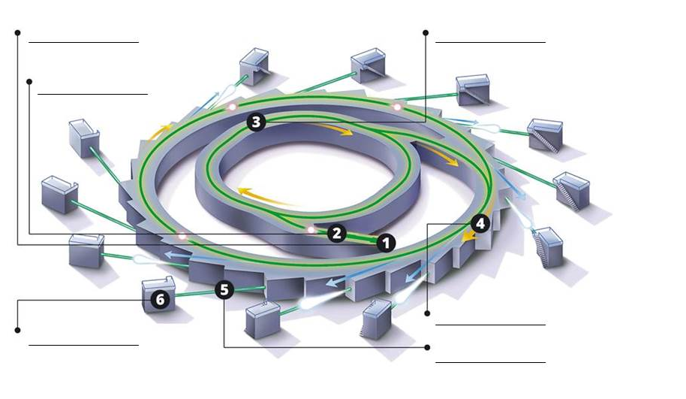
- Fill out the blanks in the flow chart with the following options:
Beamlines Electromagnets Electrons
Linear accelerator Synchrotron light
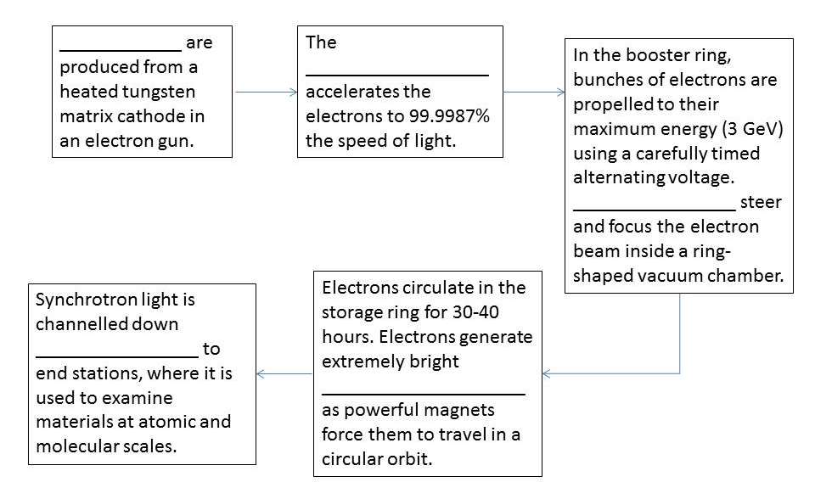
- Summarise one example of research done at the Australian Synchrotron
___________________________________________________________________
___________________________________________________________________
___________________________________________________________________
___________________________________________________________________
___________________________________________________________________

Station 4 – Virtual Reality experience of OPAL
Use the “Go” headsets, where available, to find out more about OPAL.
Radiation Detectors
At ANSTO, we use different portable devices to monitor levels of radiation.
Next to the picture of each device below, write the name of the device and a sentence or two to explain how it works.

Name of the device and how it works
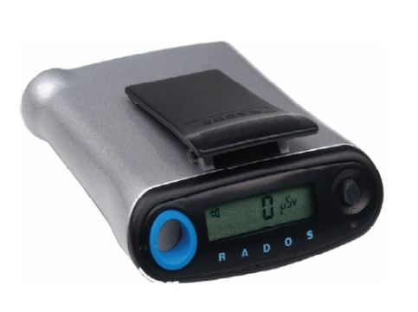
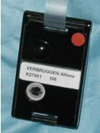

Notes
Use this space to take your own notes about areas of interest relevant to your own depth study, including information from the Q&A session after your tour.

