Mo

99

42

Molybdenum-99



U

235

92

Uranium-235



Uranium-235 makes up only 0.72% of the uranium found in nature. It is a uranium isotope that can sustain a fission chain reaction. ANSTO’s OPAL reactor uses low-enriched uranium fuel.

In nature, uranium-235 has a long half-life (700 million years) and decays by alpha emission.

**Fission of uranium-235**

Note: U-235 fission occurs in many different ways. Kr and Ba are just one example of a pair of fission fragments.

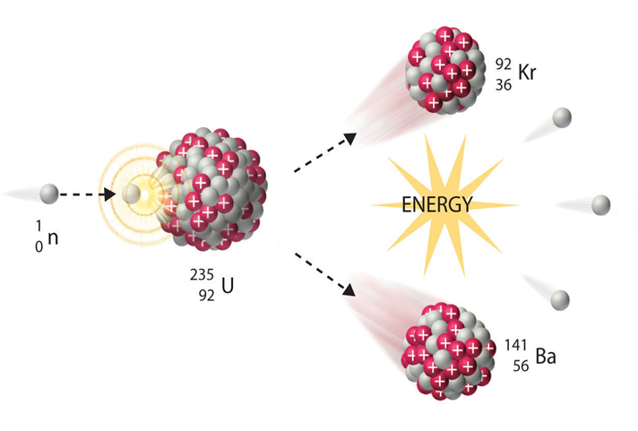

**Products and**

**research**

**Causes another U-235 to split**

**Fission (one example equation)**

**Decay**

Mo

99

42

Molybdenum-99



Molybdenum-99 is the ‘parent’ radioisotope used to make technetium-99m. It has a half-life of 66 hours and is transported in Gentech® generators to approximately 250 hospitals and medical centres across Australia.

**Production**

**Decay**

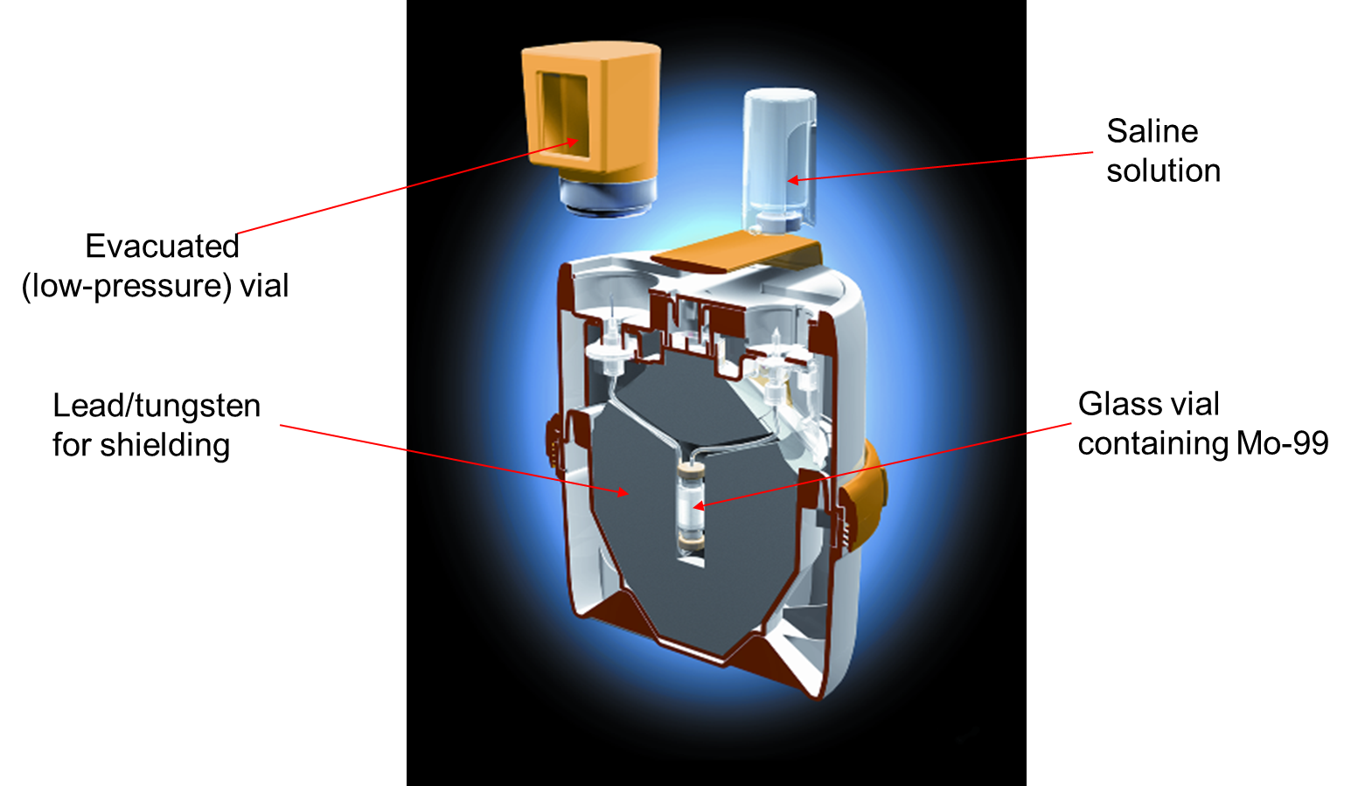

**Inside a Gentech® Generator**

Tc

99m

43

Technetium-99m



Technetium-99m is the decay product of molybdenum-99. It is a radioisotopic tag used in the diagnosis of cancers, heart disease and muscular and skeletal conditions.

Tc-99m is a pure gamma emitter and is detected with a SPECT scan. It has a half-life of 6 hours.

**Decay**

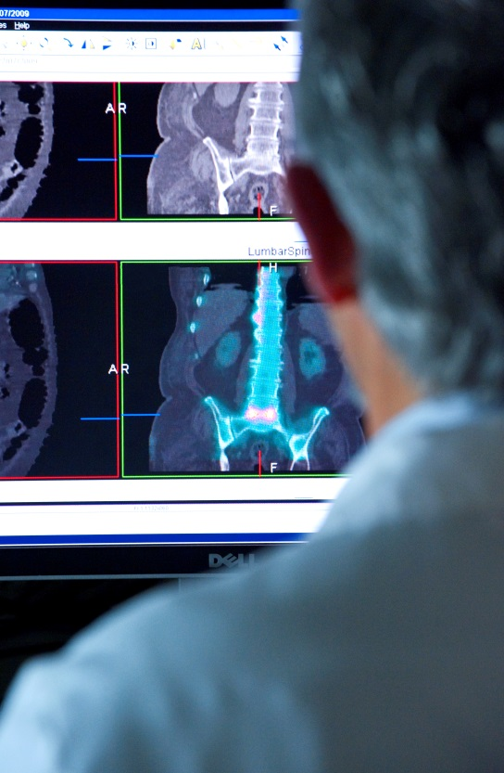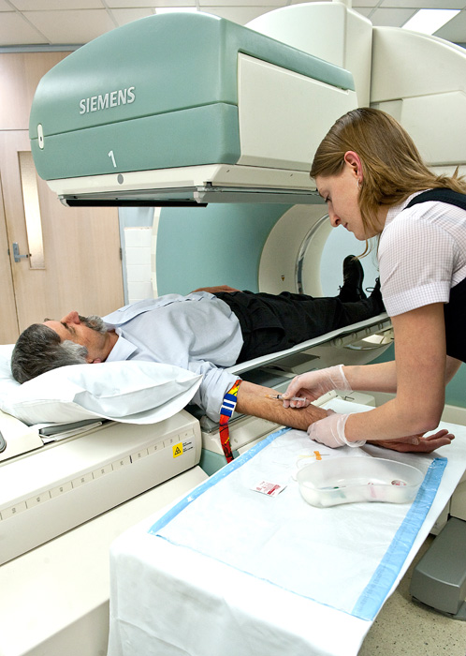

I

131

53

Iodine-131



Iodine-131 is a reactor-produced negative beta emitter used in the treatment of thyroid cancer. The thyroid absorbs iodine and the I-131 emits high energy beta particles to attack nearby cancer cells. It has a half-life of 8.02 days.

**Decay**

**Production**

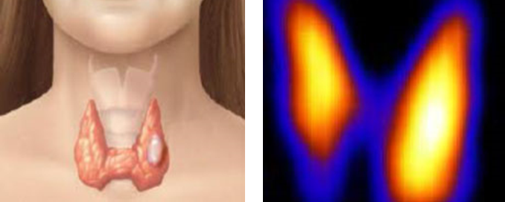

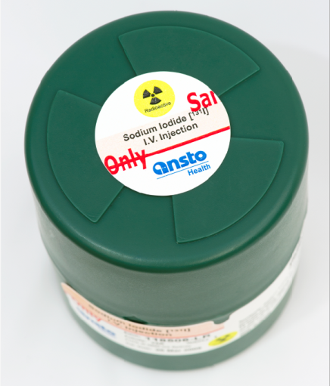

Co

60

27

Cobalt-60



Cobalt-60 is produced in a nuclear reactor by neutron irradiation of Cobalt-59. When Co-60 decays, it emits negative beta and strong gamma radiation.

Gamma irradiation from Co-60 is used to sterilise bones and soft structural tissues for transplants, as well as medical equipment.

Queensland fruit fly pupae are also sterilised by Co-60 to control outbreaks. Co-60 has a half-life of 5.27 years.

**Production**

**Decay**



C

14

6

Carbon-14



Carbon-14 is a negative beta emitter and a naturally-occurring radioisotope. One in a trillion atoms of carbon is carbon-14.

ANSTO scientists can determine the age of organic remains by measuring the ratio of radioactive carbon to non-radioactive carbon isotopes. This technique allows the dating of various objects, from coral to Egyptian mummies.

Carbon-14 has a half-life of 5,730 years.

**Decay**

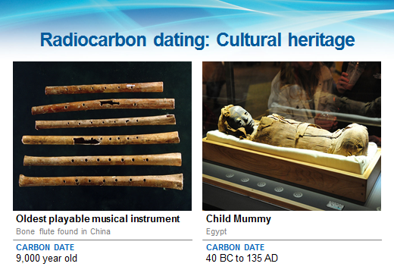

Cl

36

17

Chlorine-36



Chlorine-36 is a negative beta emitter that is used to measure the age of water up to 2 million years old.

The amount of chlorine-36 increases over time when cosmic rays hit argon in the Earth’s atmosphere.

Chlorine-36 has a half-life of 301,000 years.

**Decay**



Be

10

4

Beryllium-10



Beryllium-10 is a negative beta emitter that is used to measure the age of rocks up to 15 million years old.

The concentration of beryllium-10 builds up over time, as cosmic rays hit the surface of rocks. So, the greater the concentration of beryllium-10, the older the rock.

Beryllium-10 has a half-life of 1,390,000 years.

**Decay**

